**Task-5C: Power BI Dashboards**

Name: Yatharth Deoly

StudentId: 224207854

EmailId: [yatharthdeoly@gamail.com](mailto:yatharthdeoly@gamail.com)

Introduction

In this case study we will be learning the usage of Microsoft Power BI with help of the Airline on-time data for all flights departing from NYC in 2013. This dataset contains different features i.e.:

* `origin` –> weather station: LGA, JFK or EWR.
* `year`, `month`, `day`, `hour` -> time of recording.
* `temp`, `dewp` –> temperature and dew point in degrees Fahrenheit.
* `humid` –> relative humidity
* `wind_dir`, `wind_speed`, `wind_gust` –> wind direction (in degrees), speed and gust speed (in mph)
* `precip` –> precipitation in inches
* `pressure` –> sea level pressure in millibars
* `visib` –> visibility in miles
* `time_hour` –> date and hour (based on the year, month, day,hour fields)formatted as `YYYY-mm-dd HH:MM:SS`.

Data Cleansing

Due to a bug in the dataset, the data in the `time_hour` column are incorrectly shifted by 1 hour, so rectifying the dataset, using DAX expression that creates a new column.

*time_hour_updated = weather[time_hour]-TIME(1,0,0)*

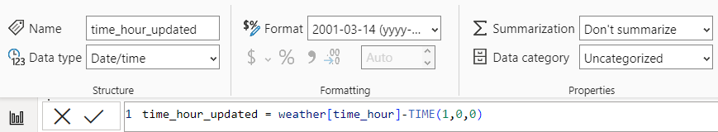

Converting columns so that they can use metric (International System of Units, SI) or derived units.

* Converting columns `temp` and `dewp`, temperature and dew point in degrees Fahrenheit to degrees Celsius.
  + *temp_celsius = (weather[temp]-32) * 5/9*

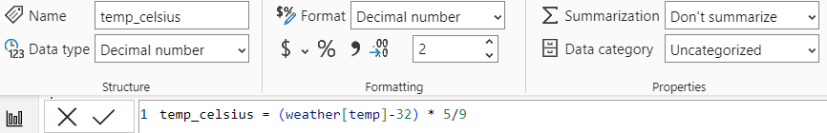

* + *dewp_celsius = (weather[dewp]-32) * 5/9*

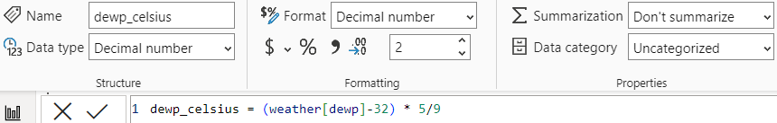

* Converting column `precip`, precipitation in inches to millimetres.
  + *precip_millimetres = weather[precip] * 25.4*

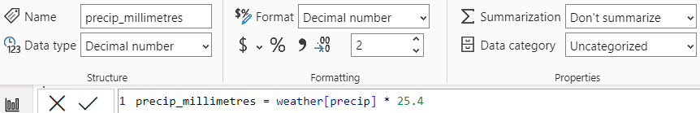

* Converting column `visib`, visibility in miles to metres.
  + *visib_metres = weather[visib] * 1609.34*

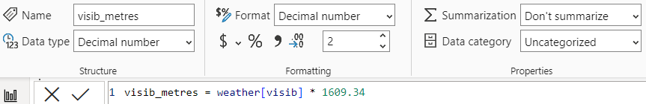

* Converting columns `wind_speed` and `wind_gust`, wind speed and wind gust speed in mph to mps.
  + *wind_speed_mps = weather[wind_speed] * 0.44704*

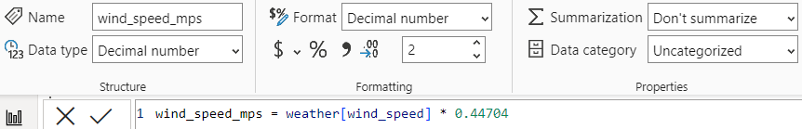

* + *wind_gust_mps = weather[wind_gust] * 0.44704*

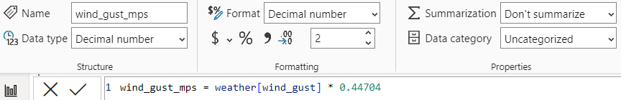

* Creating column for `wind_speed_mps` with updating max outlier as 0.
  + *wind_speed_mps_wo_max_outlier = IF(weather[wind_speed_mps] <> MAX(weather[wind_speed_mps]), weather[wind_speed_mps], 0)*

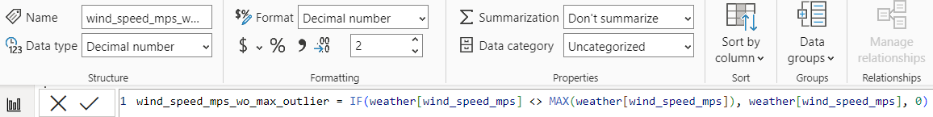

Data Visualization

* Now we will be using LGA airport from the ‘origin’ column and will be calculating daily mean of ‘wind_speed’.

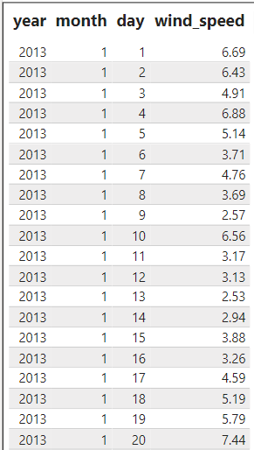

* As using above data values, will be plotting line plot, which is a graph that uses lines to connect data points to display data as points or check marks above a number line, showing the frequency of each value.

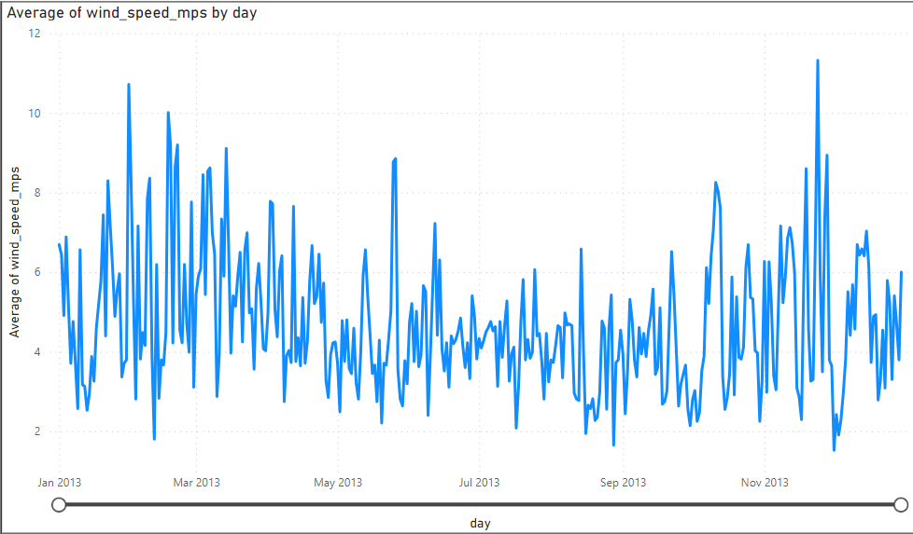

As per the visualization, we can derive:

* In 2013, daily average wind speed ranges from 1.5 to 11.5.
* Very high wind speed may lead to delay in flight.
* Fetching 10 windiest days at LGA airport with dates and the corresponding mean of daily wind speeds.

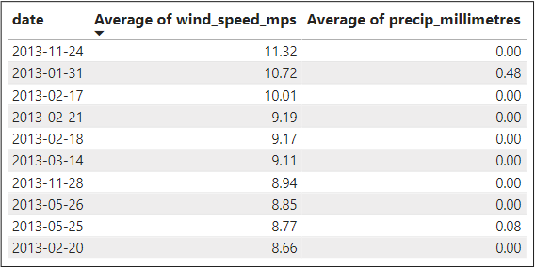

* Fetching monthly mean of wind speed for all the 3 airports.

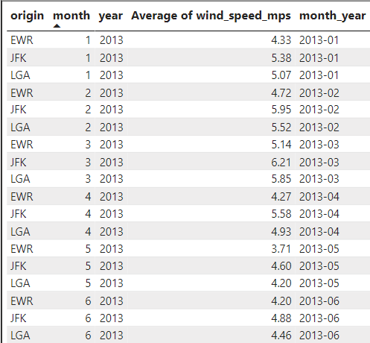

* As we have created a new dataset of monthly mean of wind speeds for all the 3 airports, now we will be plotting a graph using line plot, which is a graph that uses lines to connect data points to display data as points or check marks above a number line, showing the frequency of each value.

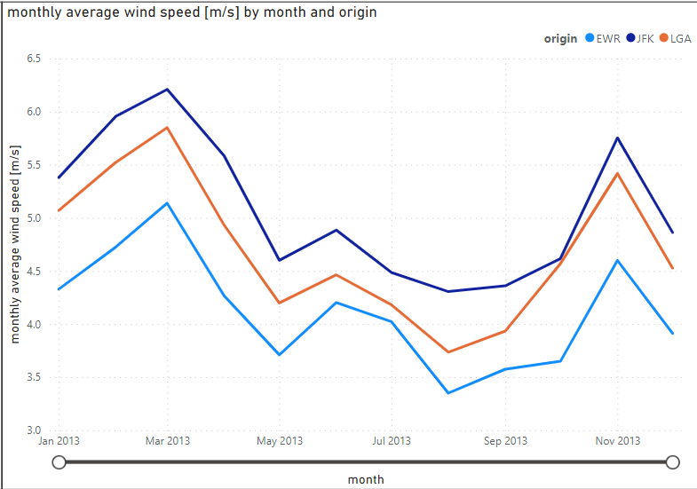

As per the visualization, we can derive:

* `JFK` origin flights have encountered more average wind speed than other airports.
* `EWR` origin flights have encountered less average wind speed than other airports.

Dashboard Link

G-drive Link: <https://drive.google.com/file/d/1xstCbVtuNMeGPO_bd7NHEalMkHAIJeTJ/view>

Power BI Link: <https://app.powerbi.com/groups/me/reports/6815e94a-51d1-4c27-8449-5cb60794e5a3/ReportSection?experience=power-bi>

Summary

In this report we have worked with the flights departing from NYC in 2013. Over this dataset we have done some exploratory data analysis, before which have pre-processed the data by modifying units and rectifying time. Using the final dataset, calculated the mean and used it with different visualization for wind checks for different airports.

In our future analysis we can add up more features, via which we can know timings, delay, reason for delay and more and how these features are affecting the other features for further predictions.

References

No references have been used for this report, except video references from courses.